Project Explanations

Verification of Thevenin’s Theorem

Objective
To verify Thevenin’s Theorem by measuring full load current

Theory

Thevenin’s Theorem states that any linear, bilateral network consisting of multiple sources and resistors can be replaced by an equivalent circuit containing a single voltage source (Vth) in series with a single resistor This simplification allows for easy analysis of the circuit's behavior when the load resistance (Rth) is changed.

Procedure (Steps)

Step 1: Original Circuit Analysis

Build the Circuit: Place your components (Battery, R1,R2,R3,R4) and connect them

Measure Load Current: Place a DC Ammeter in series with the load resistor . Run the simulation and record the current value as IL for "Circuit - I".

Note: I have taken V as 15V.
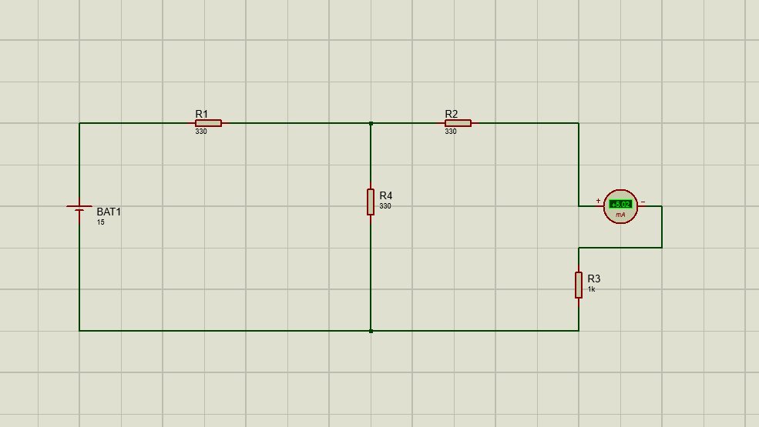

Step 2: Finding Vth (Thevenin Voltage)
- Remove the Load: Delete the load resistor R4 and the ammeter from the circuit.
- Measure Open-Circuit Voltage: Place a DC Voltmeter across the open terminals where R4 used to be.
- Simulate: Run the simulation. The reading on the voltmeter is your Vth.

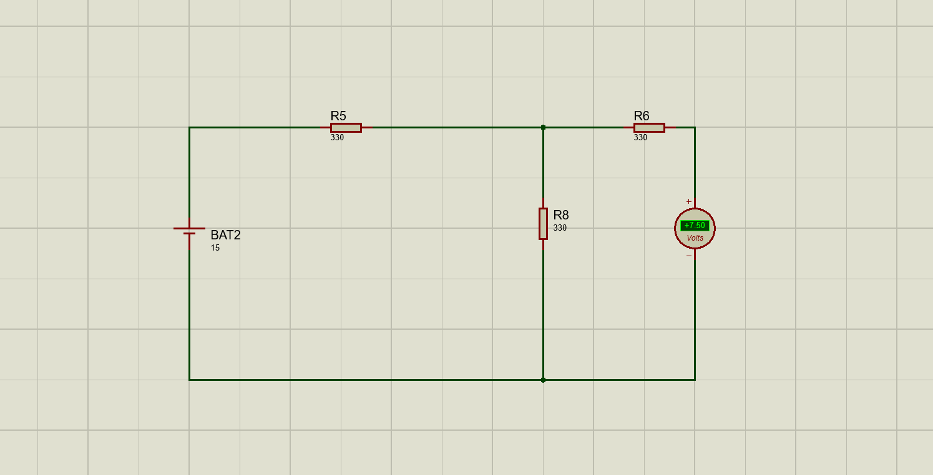

Step 3: Finding Rth (Thevenin Resistance)
- Deactivate Sources: Replace the DC Battery with a short circuit (a plain wire).
- Measure Resistance: Use an Ohmmeter component connected across the open load terminals.
- Simulate: Run the simulation. The reading is your Rth .

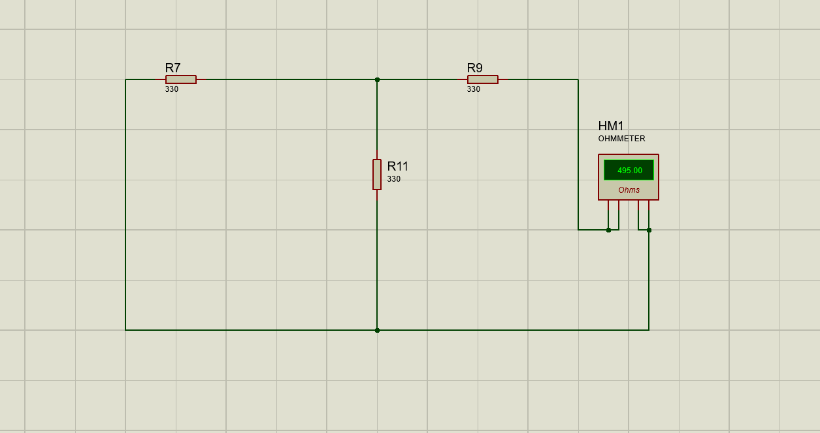

Step 4: Thevenin Equivalent Circuit
- Build the Simplified Circuit: Place a new DC Voltage source and set its value to your calculated Vth (7.5V).
- Add Rth: Place a resistor in series with the source and set it to your calculated Rth 495 Ohm
- Reconnect Load: Connect the original load resistor R4 1 Ohm and a DC Ammeter in series.
- Verify: Run the simulation. The ammeter should show the same IL (approx 5.02 mA) as the original circuit.
